*Hospital Management System for The Mayo Clinic*

Contents

1. ***Identifying stakeholders***
2. ***Write the in-scope and out-of-scope items for this software***
3. *Work Flow*
4. ***Context Diagram of Canteen Ordering system***
5. ***User Case Diagram (UML)***
6. ***Main features that need to be developed***
7. ***ER diagram of the system***
8. ***Flow Chart***
9. ***Business requirement***
10. ***Wireframes of the model***

* ***Identifying stakeholders*** **–**
* Upper management- Want to create the Hospital Management System Software so that patient can book the appointment and took other service and also want to know about bed occupancy, revenue, etc.
* Patients- Book the appointment with doctors, get information, Check bed occupancy, apply for Blood request.
* Doctor- Check up or Treatment of patients.
* Nurses and Ward boy- Give service to the patients, take care of patient.
* Staff Management- stores the names and timings of the nurses and ward boys on duty with their respective ward numbers.
* Laboratory/Blood bank/Radiation Department- Check the blood test, Report of patients, Maintain Blood, Radiation therapy to patients.
* Account Department- Billing of the patient, records of bill.
* ***Write the in-scope and out-of-scope items for this software* –**
* *IN Scope –*
* Patients with patient id can only take the treatment.
* Only available Doctors can be book for the treatment or for checkup.
* Book the bed if available.
* Apply for the Blood if required.
* Report is available on system directly no need of paper.
* Appointment reminder to the patients.
* Bill also available in the system so the patient can check the amount any time.
* Blood test is available and apply from software also.
* Blood bank.
* Radiation therapy.
* *Out of Scope-*
* Only patients with Patients Id can get the treatment.
* Only available doctors can give the treatment.
* Other hospital Doctors are not available.
* Patient with patient id can book for all the facility available in the hospital.
* Once the appointment is drop by the patient then can’t reply for that for some time.
* *Work Flow***–**

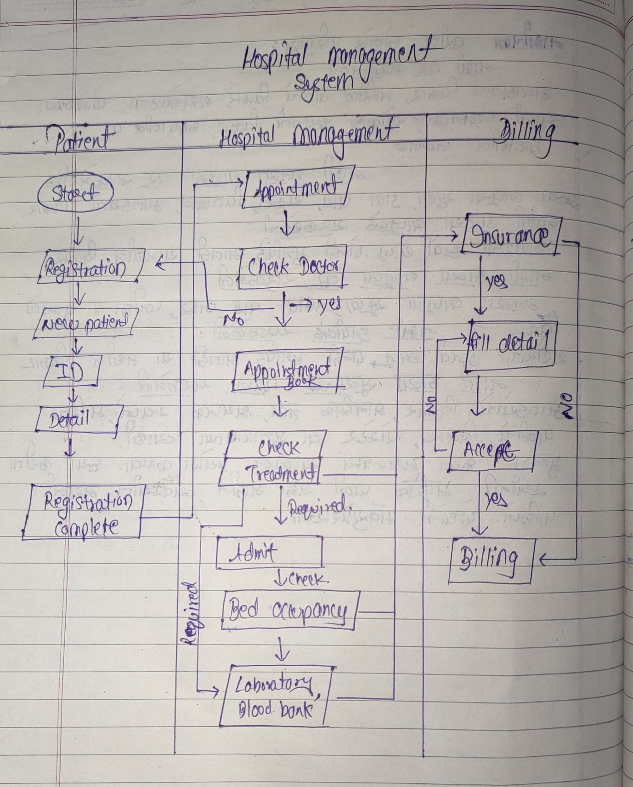

* ***Context Diagram of Canteen Ordering system* –**

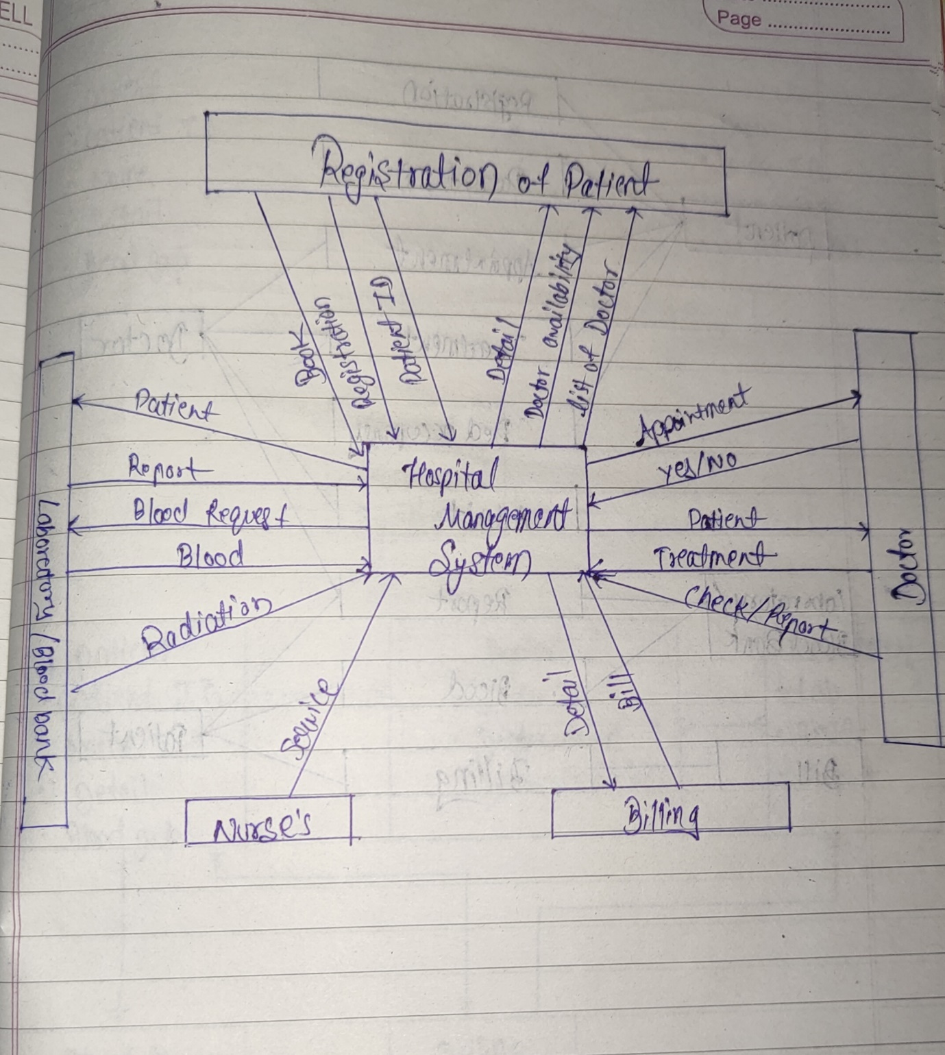

* ***User Case Diagram (UML)–***

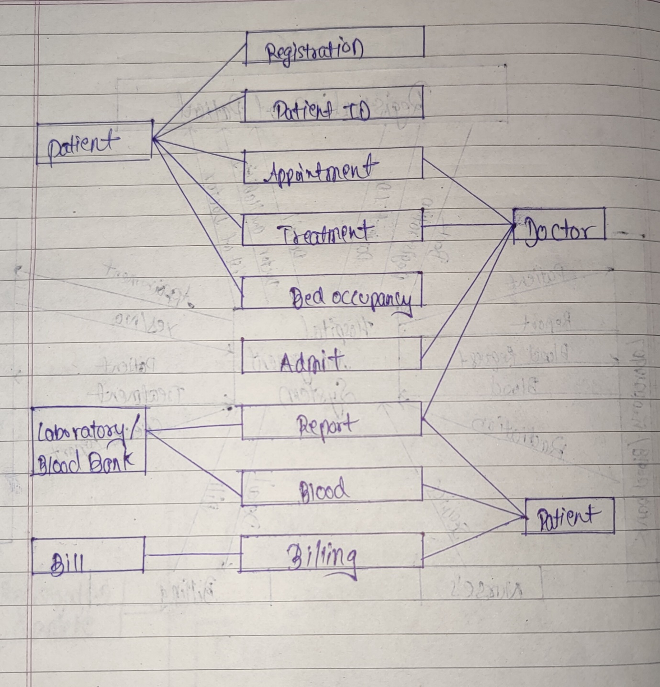

* ***Main features that need to be developed –***
* Create Hospital Management Software.
* HMS is designed to store patient’s records, show availability of beds, manage patients’ billing, scheduling a doctor’s appointment, and will bring about coordination among the different departments
* Patients can book appointment through the software.
* System shall send email and SMS reminders.
* Show the list of all the occupied and unoccupied beds in the hospital.
* Billing at the end of the treatment & at the time of discharge.
* Doctor can get the report on the software.
* Stores the names and timings of the nurses and ward boys on duty with their respective ward numbers.
* ***ER diagram of the system –***

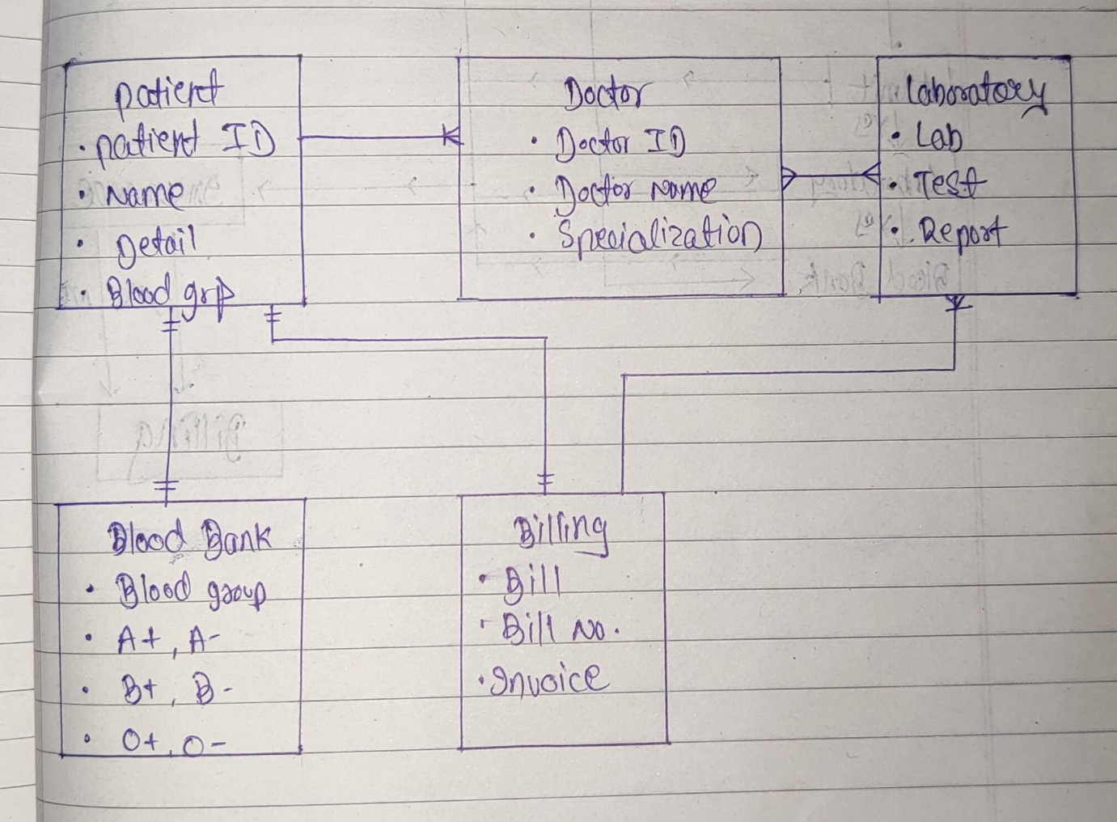

* ***Flow Chart –***

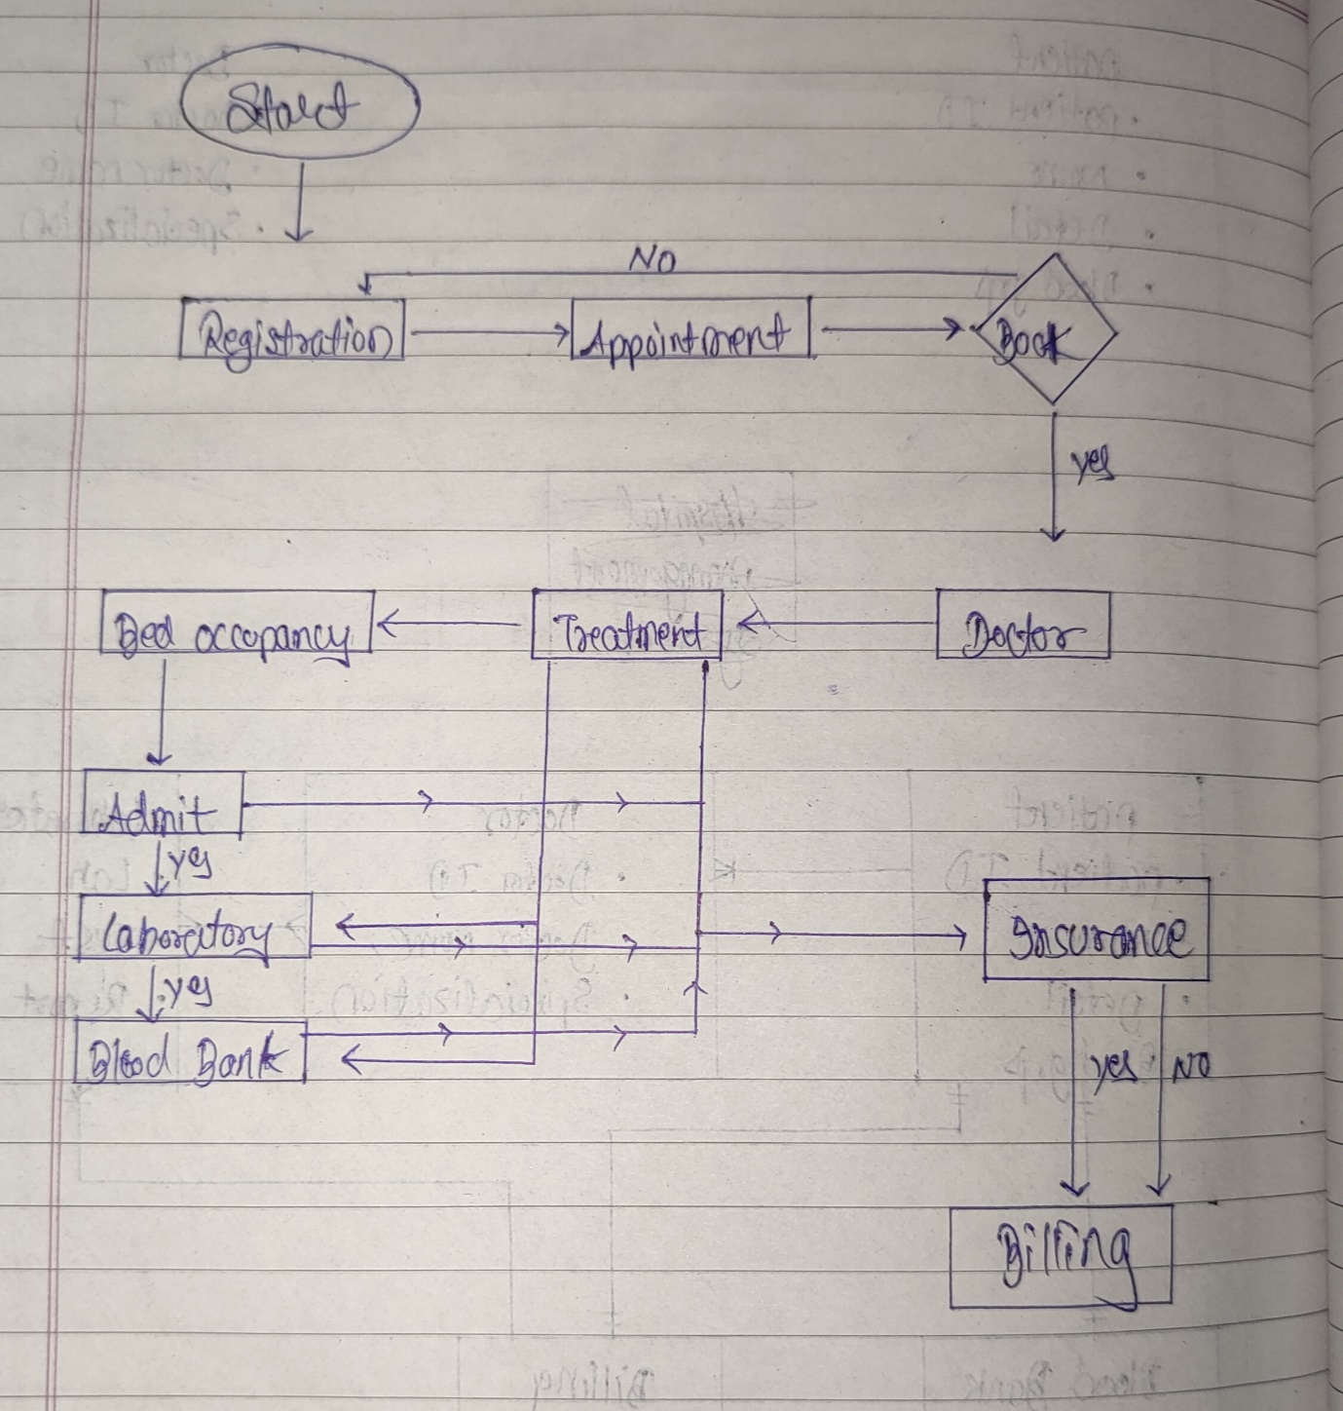

* ***Business requirements –***
* Create Hospital Management system software***.***
* HMS is designed to store patients records, show availability of beds, manage patients’ billing, scheduling a doctor’s appointment, and will bring about coordination among the different departments.
* Keeps patients’ medical records secure and stored in cloud
* Keeps track of empty and filled beds in the hospital
* Reduces documentation in the hospital
* Provide reports to senior management for better decision-making
* Reduce operating costs of the hospital.
* **Functional –**
* Patient registration.
* Registration staff give the patient id to each patient.
* Patient can book the appointment with the doctor.
* Appointment reminder.
* Check the bed occupancy.
* Update the bed occupancy.
* Billing system.
* Reports available on system.
* Information of nurses and ward boy.
* Insurance detail for the billing.
* **Non-functional -**
* MySQL Database to be used.
* The System must support 500 people using it at a time.
* The system shall give responses in 1 second
* The system shall be available all the time.
* The screens should be self-explanatory and very user friendly.
* ***Wireframes of the model –***

